Trax for The Edge
Table of Contents
Introduction 2
Versions 2
Licensing 2
Configuration Tool Download……………………………………………………………………………...2
API Key and Code………………………………………………………………………………………….2
Manual Operation 2
Configuration 3
TRAX/Edge Employee/Store Mapping…………………………………………………………………….4
TRAX Upload Scheduled Task Setup………………………………………………………………………4
Automatic Operation 4

Introduction
Trax is a customer traffic tracking system that collects data and helps you respond to your customers and get the most from each visit. Trax can now be integrated right into The Edge for automated data uploads.

Versions
Trax is supported by The Edge v. 18.0.00.26 and higher.

Licensing
The EdgeTraxExport program will not run unless your Edge license enables it. Please contact admin@edge.software or support@asjllc.com to enable Trax in your Edge license.
Configuration Tool Download
Click this link to download the configuration tool http://media.traxsales.com/TRAX.Edge.exe
API Key and Code
Once Logged into Etraxsales.com click under the Administration tab - RPG Import - The Edge https://etraxsales.com/tools/Membership/RPG.aspx sign up, once enrolled you will have to make an API Key: and API Secret:, once finished signing up put these into the designated boxes on the configuration tool listed under TRAX/Edge API Credentials Provided.
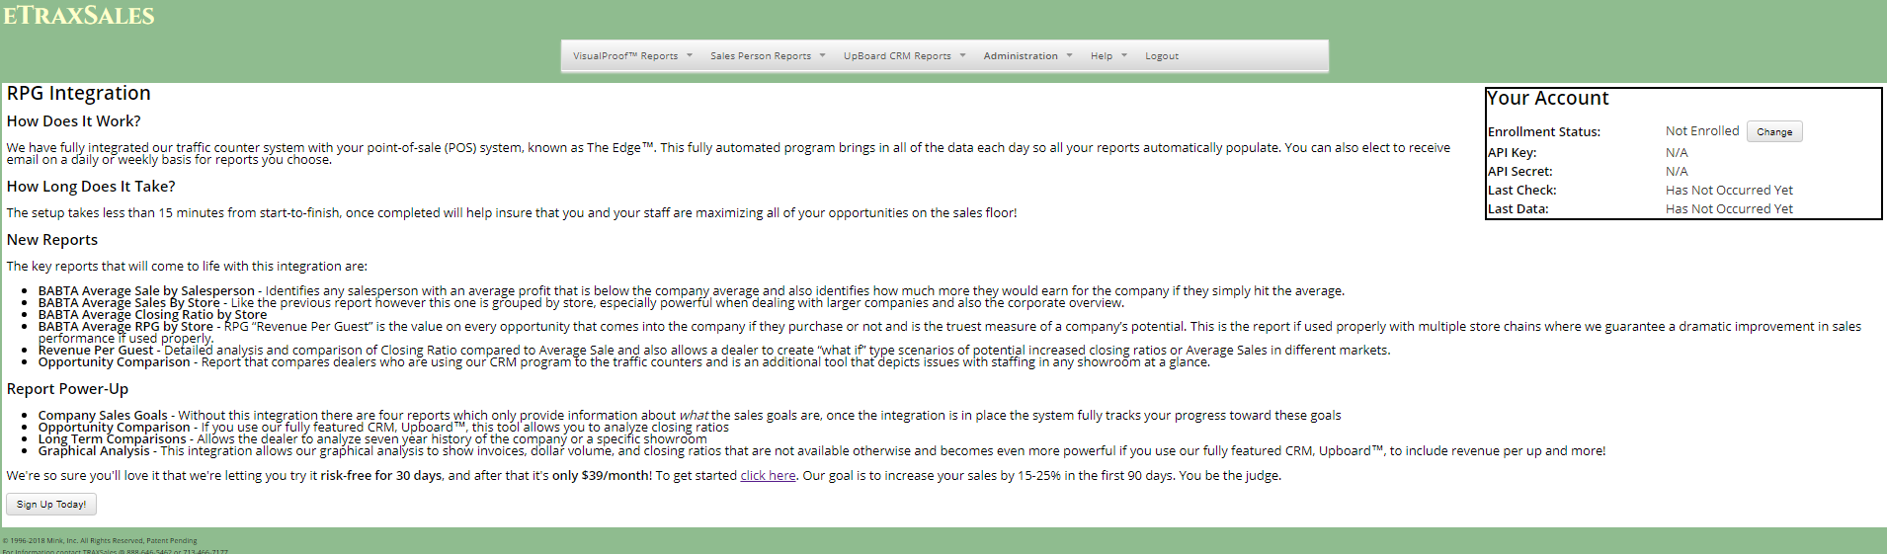
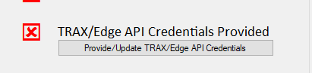

Manual Operation
The EdgeTraxExport.exe program can be found in the same folder as the Edge.exe program, usually C:\Program Files (x86)\ajsllc\Edge.
If you like, you can right click on the EdgeTraxExport.exe file and select Send To ► Desktop (create shortcut). This will create a shortcut on your desktop that you can use to launch the export program manually.

Configuration
To configure Trax, launch EdgeTraxExport.exe manually as described in the section entitled Manual Operation. The Edge Trax Exports Settings window will appear.

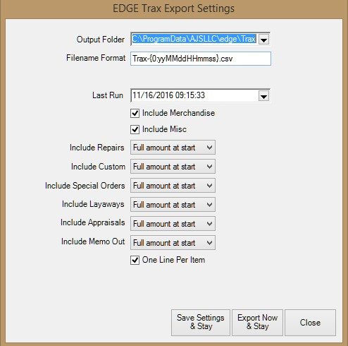
Fields and options in the Edge Trax Exports Settings window include:
Output Folder | Allows you to specify where to put the output files. By default, a “Trax” folder will be created under your Edge shared data folder.
Filename Format | Allows you to specify how to name the output files. By default, a file created on  January 1, 2015 would be named TRAX-150101.csv. Be careful when changing this specification because the characters in the braces are very specific. If you must change it, the suggested format is TRAX-{0:yymmddhhmmss}.csv.
Last Run | Shows the last time the export was generated. The program will only export sales made after this date. Set this date to the first day you have traffic counts.
Include Merchandise | Allows you to specify that straight merchandise sales should be included. This is checked by default.
Include Misc | Allows you to specify that miscellaneous sales should be included. This is not checked by default.
Include Repairs | Allows you to specify whether repairs should be included and to what degree:  - Do Not Include  - Full Amount at Start  - Each Payment Amount  - Full Amount at Pickup.
Include Custom | Allows you to specify whether custom jobs should be included and to what degree. Options are the same as those for Include Repairs.
Include Special Orders | Allows you to specify whether special orders should be included and to what degree. Options are the same as those for Include Repairs.
Include Layaways | Allows you to specify whether layaways should be included and to what degree. Options are the same as those for Include Repairs.
Include Appraisals |  | Allows you to specify whether appraisals should be included and to what degree. Options are the same as those for Include Repairs.
Include Memo Out |  | Allows you to specify whether memo items should be included and to what degree. Options are the same as those for Include Repairs.
Save Settings & Stay |  | Saves your settings, but will not run the export.
Export Now & Stay |  | Saves your settings and runs the export.
Close |  | Does not save your settings or run the export.
One Line Per Item |  | Must be checked to preclude errors. Indicates that one line is exported for each sale line.
TRAX/Edge Employee/Store Mapping
map out the customers store number will be 1 for the edge if they only have 1 store if they have more than 1 store confirm the store numbers click the map button and the employee numbers should be the exact same so double input the employee number once done click done & save then click done and save.
TRAX Upload Scheduled Task Setup
put in the password for the computer in the second line ( DO NOT REMOVE THE TOP LINE AS IF YOU DELETE IT THERE IS NO WAY TO GET IT BACK WHICH IS A PROBLEM DONT DO THIS! )for the computer so it runs at night at 2 am.

Automatic Operation
We recommend that you set up the scheduler to run the export each night after the store has closed. You can run the EdgeTraxExport program on an automatic schedule by creating a Windows Scheduled Task. You can learn more about scheduled tasks by browsing to http://windows.microsoft.com and searching for “scheduled tasks.” You can also review The Edge tip sheet entitled Setting Up a Windows task (http://docs.edgeuser.com/TIP-2012005_Setting_Up_a_Windows_Task.pdf).
Make sure that you add -silent to the end of the scheduled command to prevent the EdgeTraxExport configuration window from appearing.
Also, make sure that you have run the program manually at least once to review, edit, and save your settings.

