These emails should be separated by week and copied and pasted into personal emails to all dealers in your territory after you have asked them the 2 key TraxSales questions. Do not proceed with these emails until you know what your dealer’s true needs are.

[2 questions that a rep should ask every dealer before talking about TraxSales](https://traxsales.com/wp-content/uploads/2015/02/2-Questions-for-every-dealer-before-we-begin..docx)

**Week #1**

Subject: New Business Partnership and How TraxSales will increase your overall dealers’ sales by 15-25% in 90 days! #1 of 9

To: Addressed to you the Rep

Dear Sales Rep,

It was a great pleasure getting to know you recently and I am delighted to become a business partner with you.  I know that if we can get just half of your dealers to understand the benefits of measuring their customer traffic and assisting their salespeople in more orderly and automatic follow-up that I can easily increase your personal overall sales performance by over 15% across the board.

The first concept is setting up customer traffic counters in your dealers locations.  TraxSales is an extremely accurate, durable and reliable system under even extreme situations.  The systems are very inexpensive and will give your dealers the best ROI they have ever seen on any device they have ever invested in for their company.

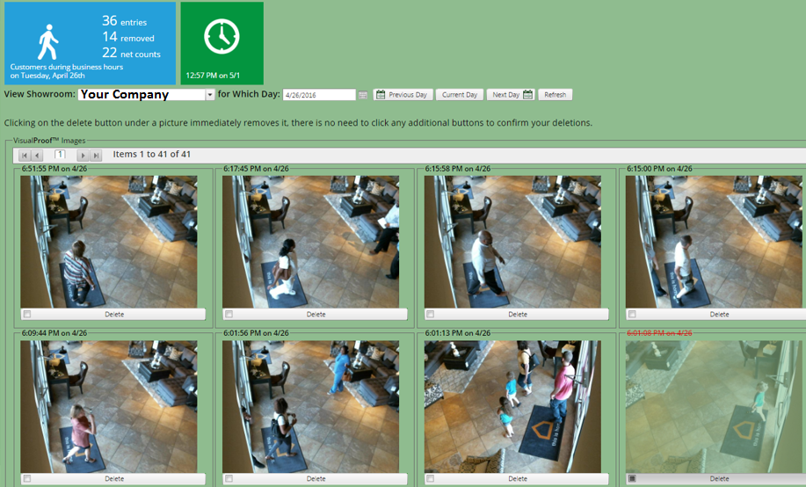

The benefits of measuring customer traffic are huge.

The average home furnishing or bedding store spends 7.4% of their gross sales in advertising and only 28% of all stores accurately measure customer traffic compared to sales coverage and really know their true closing ratios.  In other words most dealers have no idea what is working or is being wasted.

I promise you Pete, if your dealers give us a chance we will create huge improvements on every sales floor you are involved with.

The traffic counters are easy to install and the Patented CRM Trax UpBoard is so easy to learn it would take a 12 year old 15 minutes to become an expert.

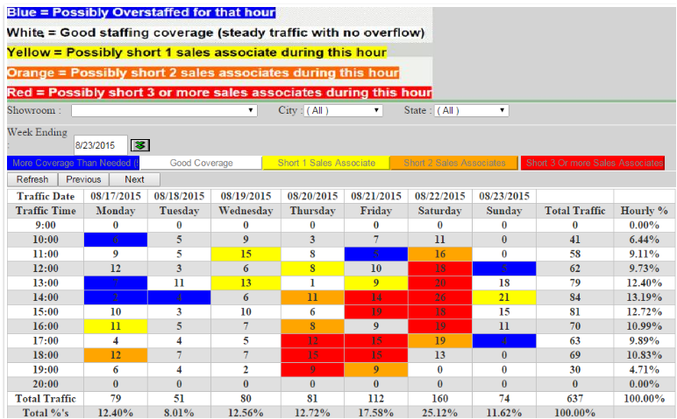

Here is what some of our clients say.

<http://traxsales.com/ashley-furniture-sales-secret/>

I promise that if we can get just ½ of your dealers using TraxSales that we will more than double everyone’s profitability including your own through increased overall sales performance.  Can you get your dealers to watch these 2 short videos?  I guarantee I will make it worth your while by helping your dealers measure that which up until now, has been impossible to measure!

Video 1: <https://traxsales.com/breaking-sales-records/>

Video 2: <https://traxsales.com/upboard/>

I will even set up the UpBoard on a free trial if your dealers purchase the traffic counter.

Regards,

Dave Mink, President



[**TRAXsales.com**](https://traxsales.com/?utm_campaign=PEMail)

**713.466.7177** office

**888.646.5462** toll-free

**281.823.9911** survey / feedback

Email: [**Dave@TRAXsales.com**](mailto:Dave@TRAXsales.com)

"Our goal is to help you grow your business through accurate and inexpensive measurement of hourly customer traffic compared to staffing, and most importantly...We help you measure and improve conversion ratios!"

**Week 2**

Subject:  How to learn your company closing ratios and why RPG “Revenue Per Guest” is the most powerful retail management tool you could ever utilize. #2 of 9

To: Addressed to you the Rep

Dear Sales Rep,

I wanted to follow-up and talk about a few of the Key reports that are automatically sent out to each of your dealers every morning by email.  There are really only 2 key reports although the system creates over 80 unique reports that guarantee improvement.  The key to success just like Fred Herman said:  KISS

My 2nd favorite is the Hot Zone Report which compares accurately how many real customers are coming in each hour compared to accurate coverage per hour on the sales floor.

Quite simply if you see blue hours you are overstaffed and possibly losing money and if you see red hours back to back you are possibly losing money.



The following is one of the 10 BABTA reports we automatically provide.  BABTA or “Below Average Brought To Average” allows you to instantly analyze your entire company at a glance and learn who immediately deserves a hearty pat on the back (or a big bonus) and who is causing your company to lose sometimes hundreds of thousands of dollars.

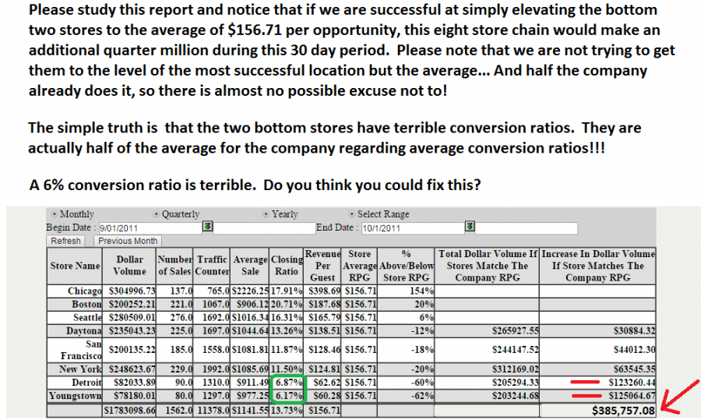

I promise that if we can get just ½ of your dealers using TraxSales that we will more than double everyone’s profitability including your own through increased overall sales performance.  Can you get your dealers to watch these 2 short videos?  I guarantee I will make it worth your while by helping your dealers by measuring that which, up until now has been impossible to measure!

<http://traxsales.com/ashley-furniture-sales-secret/>

Video 1: <https://traxsales.com/breaking-sales-records/>

Video 2: <https://traxsales.com/upboard/>

I will even set up the UpBoard on a free trial if your dealers purchase the traffic counter.

Regards,

Dave Mink, President



[**TRAXsales.com**](https://traxsales.com/?utm_campaign=PEMail)

**713.466.7177** office

**888.646.5462** toll-free

**281.823.9911** survey / feedback

Email: [**Dave@TRAXsales.com**](mailto:Dave@TRAXsales.com)

"Our goal is to help you grow your business through accurate and inexpensive measurement of hourly customer traffic compared to staffing, and most importantly...We help you measure and improve conversion ratios!"

**Week 3**

Subject:  Why TraxSales can guarantee a 15-25% increase in sales or your dealer gets their money back with a smile! #3 of 9

To: Addressed to you the Rep

Dear Sales Rep,

I had a sales meeting the recently with a 10 store chain and I must share a tragic revelation that was realized from one of the BABTA reports that we were analyzing at the time.

Normally during these training sessions I will focus on just one location (with permission) and use that store to more easily show everyone how to use the tools we provide.  I have included the recordings from this meeting below for your listening pleasure.

We were looking at one of the BABTA reports we provide that ranks all salespeople in the company by the Revenue Per Guest totals.  This report measures the dollar value of every  opportunity that speaks with any salesperson.  We discovered a new salesperson Mary (name changed to protect the innocent) that had spoken with 70 customers and had only done $5400 in total sales.   When the owner asked the store manager about this the reply was that we let her go last week.  After further review we discovered that Mary had been with the company for over four months and using BABTA we discovered that she had cost the company over $60,000 in lost sales (compared to just the average salesperson in the company.  If you compared Mary to one of the top performers in the company Mary lost the company over $100,000 during this short period.

The real tragedy is discovering why this phenomenon occurs on almost every sales floor in the retail world.  If a salesperson has not been trained properly on the simple basics of the greeting and opening the sale properly then they are going to be rejected a very high percentage of the time.  Many salespeople when they get the old Heisman move (the customer holds their hand up like they are blocking a tackler and says.  Hi There, We are “JUST LOOKING”  without proper training this salesperson will talk sometimes with many more customers than your top salespeople and now you can track this and hold your store managers accountable for properly training these wonderful new salespeople.

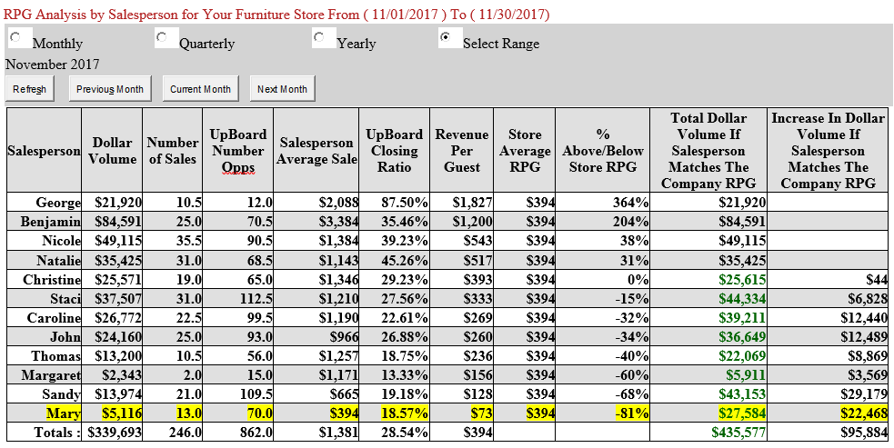

I promise that if we can get just ½ of your dealers using TraxSales that we will more than double everyone’s profitability including your own through increased overall sales performance.  Can you get your dealers to watch these 2 short videos?  I guarantee I will make it worth your while by helping your dealers by measuring that which up until now, has been impossible to measure!

<http://traxsales.com/ashley-furniture-sales-secret/>

Video 1: <https://traxsales.com/breaking-sales-records/>

Video 2: <https://traxsales.com/upboard/>

I will even set up the UpBoard on a free trial if your dealers purchase the traffic counter.

Regards,

Dave Mink, President



[**TRAXsales.com**](https://traxsales.com/?utm_campaign=PEMail)

**713.466.7177** office

**888.646.5462** toll-free

**281.823.9911** survey / feedback

Email: [**Dave@TRAXsales.com**](mailto:Dave@TRAXsales.com)

"Our goal is to help you grow your business through accurate and inexpensive measurement of hourly customer traffic compared to staffing, and most importantly...We help you measure and improve conversion ratios!"

**Week 4**

Subject:  How much down time is there on a retail sales floor?  Also how’s it going with the steps of the sale in your stores? #4 of 9

To: Addressed to you the Rep

Dear Sales Rep,

I wanted to share with you a couple money making tools that we will automatically email daily to your dealers to dramatic improvement.

We have just added these to our auto list because they are so good.

Here is a report taking your time clock to a whole new level.  What do you think is the most interesting feature on this report?  My answer is at the bottom of this email **.

Time With Customers for Your Company From ( 12/01/2016 ) To ( 12/31/2016 )

|  |  |  |  |  |  |  |  |  |  |  |  |  |  |  |  |  |  |  |  |  |  |  |  |  |  |  |  |  |  |  |  |  |  |  |  |  |  |  |  |  |  |  |  |  |  |  |  |  |  |  |  |  |  |  |  |  |  |  |  |  |  |  |  |  |  |  |  |  |  |  |  |  |  |  |  |
| --- | --- | --- | --- | --- | --- | --- | --- | --- | --- | --- | --- | --- | --- | --- | --- | --- | --- | --- | --- | --- | --- | --- | --- | --- | --- | --- | --- | --- | --- | --- | --- | --- | --- | --- | --- | --- | --- | --- | --- | --- | --- | --- | --- | --- | --- | --- | --- | --- | --- | --- | --- | --- | --- | --- | --- | --- | --- | --- | --- | --- | --- | --- | --- | --- | --- | --- | --- | --- | --- | --- | --- | --- | --- | --- | --- |
| |  | | --- | |  | |  | | |  |  |  |  |  |  |  |  | | --- | --- | --- | --- | --- | --- | --- | --- | | **Sales Person** | **Total Time Hrs** | **Time On Deck Hrs** | **Time w/ Customers Hrs** | **Avg Time w/ Customers Mins** | **Number of Opportunities** | **Number of Sales** | **Closing Ratio** | | **Benjamin** | **127** | **62** | **65** | **21** | **151.0** | **39.0** | **25.83%** | | **George** | **138** | **85** | **53** | **27** | **107.0** | **24.0** | **22.43%** | | **Betsy** | **118** | **78** | **40** | **22** | **99.5** | **17.5** | **17.59%** | | **Trixie** | **106** | **65** | **41** | **27** | **85.5** | **25.5** | **29.82%** | | **Nicole** | **148** | **90** | **58** | **25** | **135.0** | **36.0** | **26.67%** | | **Taylor** | **135** | **74** | **61** | **31** | **111.0** | **23.0** | **20.72%** | | **Natalie** | **124** | **52** | **72** | **32** | **116.0** | **35.0** | **30.17%** | | **Totals for Period :** | **896** | **506** | **390** | **26** | **805.0** | **200.0** | **24.84%** | | |

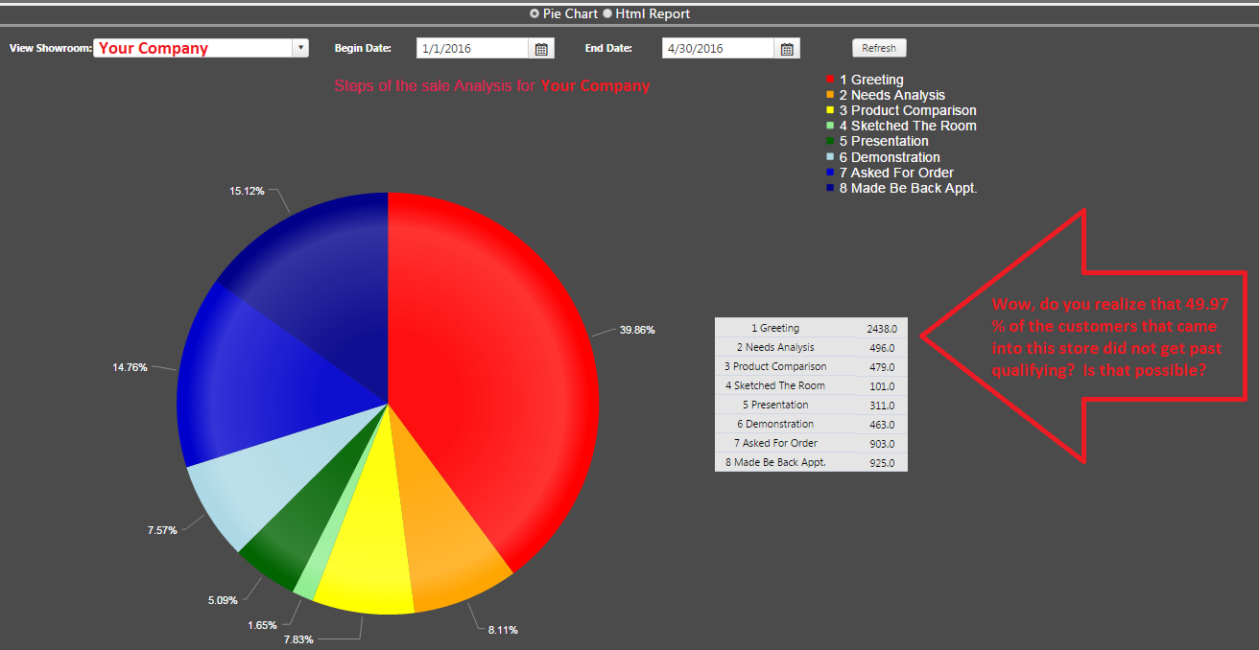

     **  I think the most amazing feature on this time with customers report is the amount of time on deck just waiting for customers to come in.  What are your salespeople doing during this down time?

I promise that if we can get just ½ of your dealers using TraxSales that we will more than double everyone’s profitability including your own through increased overall sales performance.  Can you get your dealers to watch these 2 short videos?  I guarantee I will make it worth your while by helping your dealers by measuring that which up until now, has been impossible to measure!

<http://traxsales.com/ashley-furniture-sales-secret/>

Video 1: <https://traxsales.com/breaking-sales-records/>

Video 2: <https://traxsales.com/upboard/>

I will even set up the UpBoard on a free trial if your dealers purchase the traffic counter.

Regards,

Dave Mink, President



[**TRAXsales.com**](https://traxsales.com/?utm_campaign=PEMail)

**713.466.7177** office

**888.646.5462** toll-free

**281.823.9911** survey / feedback

Email: [**Dave@TRAXsales.com**](mailto:Dave@TRAXsales.com)

"Our goal is to help you grow your business through accurate and inexpensive measurement of hourly customer traffic compared to staffing, and most importantly...We help you measure and improve conversion ratios!"

**Week 5**

Subject:  Do you want to hold your advertisers accountable when they screw up? #5 of 9

To: Addressed to you the Rep

Dear Sales Rep,

There is finally a way to find out what if really happening regarding advertising.  I hope this gets you as excited as it does me!  It’s a money making machine!

2. [NOW YOU CAN HOLD YOUR ADVERTISERS ACCOUNTABLE FOR POOR PERFORMANCE and ‘receive make goods’ when your advertisers screw up!](http://traxsales.com/double-your-advertising-effectiveness-with-traxsales-a-study-of-benefit-3/)

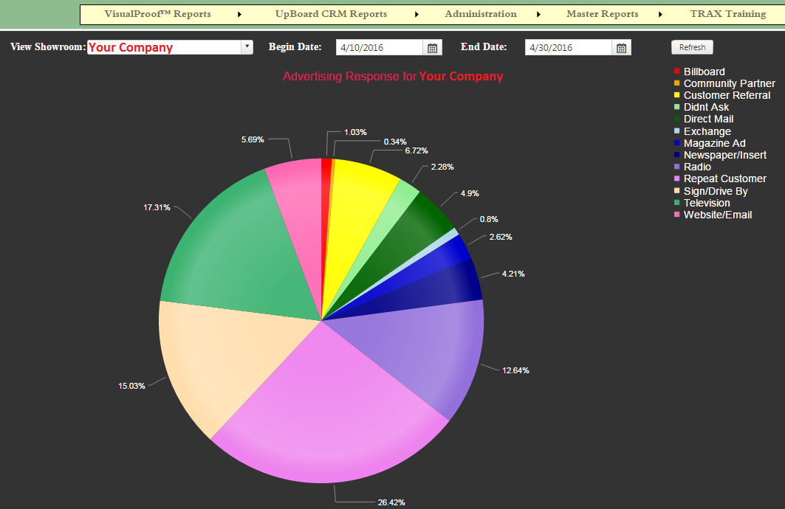

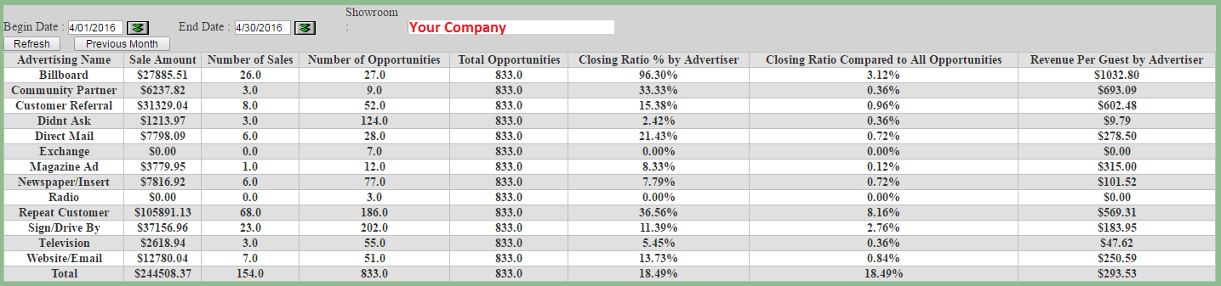

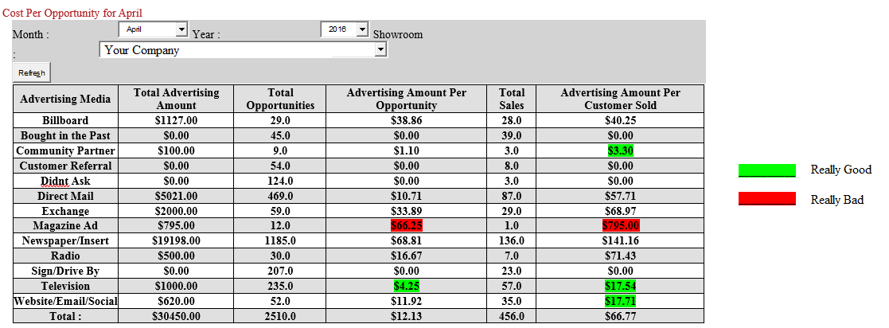

I promise that if we can get just ½ of your dealers using TraxSales that we will more than double everyone’s profitability including your own through increased overall sales performance.  Can you get your dealers to watch these 2 short videos?  I guarantee I will make it worth your while by helping your dealers by measuring that which up until now, has been impossible to measure!

<http://traxsales.com/ashley-furniture-sales-secret/>

Video 1: <https://traxsales.com/breaking-sales-records/>

Video 2: <https://traxsales.com/upboard/>

I will even set up the UpBoard on a free trial if your dealers purchase the traffic counter.

Regards,

Dave Mink, President



[**TRAXsales.com**](https://traxsales.com/?utm_campaign=PEMail)

**713.466.7177** office

**888.646.5462** toll-free

**281.823.9911** survey / feedback

Email: [**Dave@TRAXsales.com**](mailto:Dave@TRAXsales.com)

"Our goal is to help you grow your business through accurate and inexpensive measurement of hourly customer traffic compared to staffing, and most importantly...We help you measure and improve conversion ratios!"

**Week 6**

Subject:  The importance of follow-up and the IGE and how this will immediately increase sales. #6 of 9

To: Addressed to you the Rep

Dear Sales Rep,

The acronym IGE (pronounced IGGY) stands for "Information Gathering Efficiency".  We assume that when you make a sale you will get the customers personal information over 99% of the time.  What IGE does is measure how many times you get quality information when you do not make a sale.

We also know that you will never get personal information on every prospective customer who enters your store.  But I think you will agree that if you are sure you will not make a sale the first time in that you should try to develop enough of a relationship that you can gain a new prospective customers trust so you can follow-up.  We work with many dealers who have extremely high closing ratios and have IGE percentages over 70%.  This is where the easiest touchdowns are made.

If you don't close the sale and you don't get follow-up information you are dead in the water.  Maybe they will get on the Be Back Bus, or the occasional salesperson will sprinkle just the right amount of be-back dust on them, but most of the time we all know that they won't.

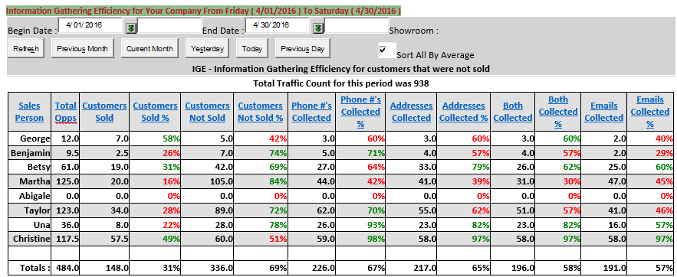

|  |
| --- |
|  |

After you have the Hot Zone report set correctly and staffing is adequate, this report is all that you should be focusing on for the next three weeks with TRAX.  This is a very critical time and your level of success in this area will determine your long term success with the system.  You should consider a spiff contest for your top salespeople for these first three weeks.  You should make this worthwhile for all the winners and you should also reward the manager with a bonus if they hit the goal.  I also have a very successful dealer that also pays his salespeople $1 for every unsold customer they put into TRAX.  He does spot check to insure accuracy but his return on investment here is huge.  Another thing successful dealers do is have a monthly or quarterly drawing for a $500-1000 gift certificate, giving the customer additional incentives to provide their personal information.  See additional ideas in the training section provide when you sign up.

I promise that if we can get just ½ of your dealers using TraxSales that we will more than double everyone’s profitability including your own through increased overall sales performance.  Can you get your dealers to watch these 2 short videos?  I guarantee I will make it worth your while by helping your dealers by measuring that which up until now, has been impossible to measure!

<http://traxsales.com/ashley-furniture-sales-secret/>

Video 1: <https://traxsales.com/breaking-sales-records/>

Video 2: <https://traxsales.com/upboard/>

I will even set up the UpBoard on a free trial if your dealers purchase the traffic counter.

Regards,

Dave Mink, President



[**TRAXsales.com**](https://traxsales.com/?utm_campaign=PEMail)

**713.466.7177** office

**888.646.5462** toll-free

**281.823.9911** survey / feedback

Email: [**Dave@TRAXsales.com**](mailto:Dave@TRAXsales.com)

"Our goal is to help you grow your business through accurate and inexpensive measurement of hourly customer traffic compared to staffing, and most importantly...We help you measure and improve conversion ratios!"

**Week 7**

Subject:  Sales Goals and how automating these could be the best thing you have ever done for your company! #7 of 9

To: Addressed to you the Rep

Dear Sales Rep,

Yogi Berra once said: “If you don’t know where you are going you will probably end up somewhere else”  Most of us use an ineffective monthly goal that most salespeople ignore until about the third week and by then sometimes it’s too late.  Trax is a fully automatic (easily edited) weekly goal program that tells everyone exactly where the team is in relation to set goals and creates a sense of fun competition that creates results.

Vince Lombardi once said, The difference between being truly great at something and being average is a very small fraction.  It is a matter of inches of additional effort on every play.  The difference is a solid work ethic, developing a habit of good daily skills and intelligent goal setting.

The TRAXsales Goals Program permits you to easily take your monthly goal and automatically break it down by week.  It then permits you to create a minimum performance level.  When a sales person is above their goal for the week, they get two thumbs up, when they are below their goal yet above the minimum they get one thumb up.  If they are below their minimum for the week, they receive a caution sign.  When a salesperson has performed way over their goal for the week they receive a double eagle symbol.  You can adjust the double eagle goal to any percentage over goal you desire.

TRAX provides a report, which automatically displays these goals by sales person and for the entire showroom.  This chart is automatically emailed weekly to each salesperson and the master should be displayed prominently where all salespeople can see it.  This report does not display any numbers, but does let everyone know how they compare.  It promotes friendly good old fashioned competition.  This is also an excellent report for comparing one showroom to another for multiple location operations so you can compare your sales management teams effectiveness on a monthly basis.  Our spiff contest works very well for your monthly managers meetings.  Especially if you like to bonus your showroom managers based on sales performance.

The link below is to the best Spiff Contest you have every held in your company!  Do you know where the word spiff came from?   [Trax Weekly Goal Spiff Contest](http://training.traxsales.com/Training/TRAX%20Spiff%20Contest.html)

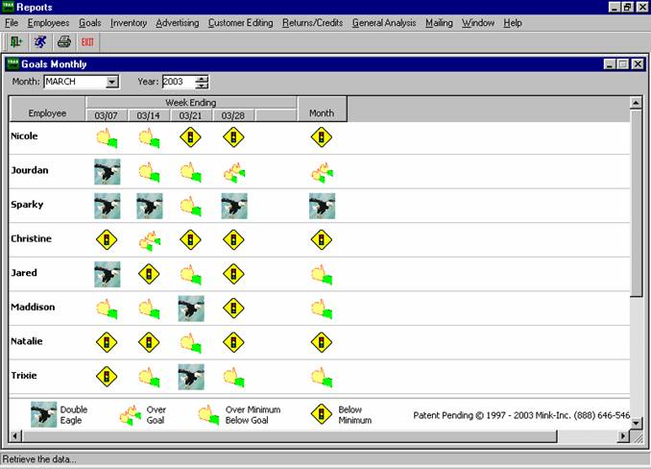

I promise that if we can get just ½ of your dealers using TraxSales that we will more than double everyone’s profitability including your own through increased overall sales performance.  Can you get your dealers to watch these 2 short videos?  I guarantee I will make it worth your while by helping your dealers by measuring that which up until now, has been impossible to measure!

<http://traxsales.com/ashley-furniture-sales-secret/>

Video 1: <https://traxsales.com/breaking-sales-records/>

Video 2: <https://traxsales.com/upboard/>

I will even set up the UpBoard on a free trial if your dealers purchase the traffic counter.

Regards,

Dave Mink, President



[**TRAXsales.com**](https://traxsales.com/?utm_campaign=PEMail)

**713.466.7177** office

**888.646.5462** toll-free

**281.823.9911** survey / feedback

Email: [**Dave@TRAXsales.com**](mailto:Dave@TRAXsales.com)

"Our goal is to help you grow your business through accurate and inexpensive measurement of hourly customer traffic compared to staffing, and most importantly...We help you measure and improve conversion ratios!"

**Week 8**

Subject: Next Item Needed or as we lovingly call it the “NIN” and how this concept could more than double your sales every year! #8 of 9

To: Addressed to you the Rep

Dear Sales Rep,

Next Item Needed is the heart of TRAX and if used properly can and will dramatically increase your sales! NIN is a concept that is foreign to most salespeople, but it is the secret that the multimillion dollar producers in this industry jealously hidden from everyone.  Once you make a sale it’s human nature to get them out the door.  The question sometimes becomes, what if I keep them in the store with a couple more questions and they change their mind about the original purchase?  I am here to tell you that 99% of all customers truly appreciate someone looking out for them in the future and most of the time if NIN is done right it cements an ongoing quality relationship. IE: for a very small amount of additional work the ROI is phenomenal! Keep in mind TRAX automatically makes this happen for each salesperson every day!  
  
This is a concept invented by John F. Lawhon, author of The Selling Bible and you should buy this book at <http://www.sellingretailinc.com/> it is the best book I have ever read on the subject of selling. Mr. Lawhon before writing this book spent hundreds of hours interviewing the top multimillion dollar producers in the Home Furnishings Industry. He discovered one fantastic common denominator and this is a secret that most top producers did not want to share. John discovered that all of these top producers had a common skill where they asked every customer who just purchased before they went out the door what they might be interested in for their home in the future. This is from page 71 and you should memorize these words.  
  
Mrs. Jones, because I do like to help my customers any way I can, do you mind telling me what you think you will be buying next for your home? Then I can keep my eye out for you. If it goes on special or we get something in I think you will like better, I’ll give you a ring or drop you a line. You may want to stop in and take a look at it. The customer will tell that salesperson what it will be every time and they won’t even have to think about it.  
  
If you do it with those exact words, it will work nearly every single time.  
  
The professional will then say: “Mrs. Jones, as long as you are here, would you mind walking through that department on your way out and show me what would best meet your needs, then I will have an even better idea what to be looking for.” John says it is a rare customer who doesn’t.  
  
When you learn this NIN and enter it into eTRAX we will remind you on the proper day to follow-up and what exactly to do next.

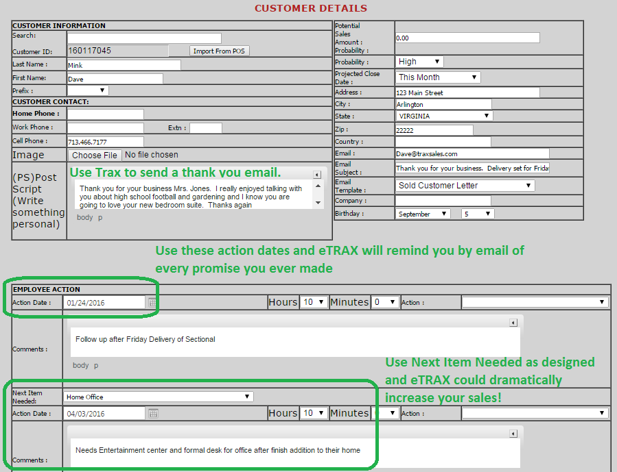

Please remember that it takes only 15 minutes to completely train any sales team on how to become completely proficient on your sales floor and I will do all the training for you with my easy step by step videos.

I promise that if we can get just ½ of your dealers using TraxSales that we will more than double everyone’s profitability including your own through increased overall sales performance.  Can you get your dealers to watch these 2 short videos?  I guarantee I will make it worth your while by helping your dealers by measuring that which up until now, has been impossible to measure!

<http://traxsales.com/ashley-furniture-sales-secret/>

Video 1: <https://traxsales.com/breaking-sales-records/>

Video 2: <https://traxsales.com/upboard/>

I will even set up the UpBoard on a free trial if your dealers purchase the traffic counter.

Regards,

Dave Mink, President



[**TRAXsales.com**](https://traxsales.com/?utm_campaign=PEMail)

**713.466.7177** office

**888.646.5462** toll-free

**281.823.9911** survey / feedback

Email: [**Dave@TRAXsales.com**](mailto:Dave@TRAXsales.com)

"Our goal is to help you grow your business through accurate and inexpensive measurement of hourly customer traffic compared to staffing, and most importantly...We help you measure and improve conversion ratios!"

**Week 9**

Subject: Summation of all the tools in the TraxSales Arsenal and why guaranteeing a 15-25% increase in 90 days and doing it again every year is a layup! #9 of 9

To: Addressed to you the Rep

Dear Sales Rep,

We are the only company in the world who provides your dealers the highest quality, most accurate and reliable customer traffic counter in the world and combines this with our patented CRM UpBoard system.  This guarantees that on top of accurately measuring the true sales potential at each store we also provide each sales associate with cutting edge follow-up tools and measurements that guarantee dramatic sales improvement.

# The Problem with Veteran Salespeople

[](https://traxsales.com/wp-content/uploads/2014/09/videoArgus_clip_image002_00001.jpg)Veteran salespeople are sometimes very difficult to manage, especially if it’s your opinion against theirs.  Sometimes even though you convincingly win the argument their personalities will not let them let go; if there are not indisputable facts.  John Adams said: “Facts are stubborn things, but those are the facts”.

As a manager and owner of an eight store chain for many years in Texas I can’t tell you how many times I ended discussions with a strong personality from my sales division and even though the buck stopped with me sometimes you both have to agree to disagree.

If you tell a store manager or veteran salesperson that their closing ratio is lower than they think it is, you better be able to support it with facts or don’t even start the conversation.

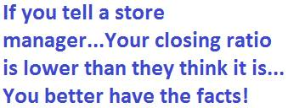

At Trax we understand this dilemma completely and equip you with exact verifiable extremely accurate information about how many true customers visit your company with time stamps and weekly summaries.

I had a sales manager once tell me that he had three of his top salespeople come up to him and inform him that corporate headquarters was clueless about how to advertise and that if they didn’t get it together and bring in more traffic we will all be forced to leave for greener pastures.

This sales manager then said: Let me show you all something about the last couple days that might surprise you.  We have 12 salespeople on the sales floor on average every hour and if you look at these photos we have had over 150 customers per day and our overall closing ratios are less than 10%.

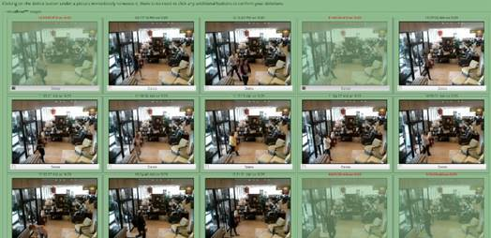

As you can see I have also removed all of the non-customer counts like all salespeople the mail man and even the manufacturer reps that came in yesterday.  Don’t you agree that we have plenty of potential customers that are coming in?  They all agreed that if we could figure out how to improve our closing ratios and average sale that there is a great opportunity to improve!  The sales manager said he felt very good about the discussion until one of the salespeople said: “I wonder if they could try to bring in better potential customers who had more disposable income”?  Well that’s another story…

Here’s the primary difference between a standard infrared traffic counter (body heat detection) such as Shopper Trak, Prodco and all the others, the traffic counts they give you can’t be verified and some are manually adjusted before you see them so that they always look good.  But how can you trust them?

[](https://traxsales.com/wp-content/uploads/2014/09/videoArgus_clip_image008_0000.jpg)Trax with patent pending Visual Proof technology gives you live feedback with up to the second Verifiable Proof of true customer activity.  There is nothing more powerful than having the ability in a meeting to say Wow… We had 1000 real customers last week and only sold 90?  Is this possible?  If true how can we fix it?  Owner talking to his sales management team… Do you realize that if we can figure out how to sell just 5 more customers per hundred that we will increase our total sales by over 50%.  The first thing we must do is make sure the pictures are accurate and then make sure all sales are entered into the reports (5 second import) then we will know the truth.

With TRAX you simply select and grey out the salespeople and other non-customer pictures and all reports are then extremely accurate.  W. Edwards Deming once said: “Without facts you are just another person with an opinion”.   And John F. Lawhon said:  “If you can measure something, you can improve it”.

Give me a call and let us show you how to dramatically inspire your sales teams and help them improve their performance.

713-466-7177 or 888-534-1253

I promise that if we can get just ½ of your dealers using TraxSales that we will more than double everyone’s profitability including your own through increased overall sales performance.  Can you get your dealers to watch these 2 short videos?  I guarantee I will make it worth your while by helping your dealers by measuring that which up until now, has been impossible to measure!

<http://traxsales.com/ashley-furniture-sales-secret/>

Video 1: <https://traxsales.com/breaking-sales-records/>

Video 2: <https://traxsales.com/upboard/>

I will even set up the UpBoard on a free trial if your dealers purchase the traffic counter.

Regards,

Dave Mink, President



[**TRAXsales.com**](https://traxsales.com/?utm_campaign=PEMail)

**713.466.7177** office

**888.646.5462** toll-free

**281.823.9911** survey / feedback

Email: [**Dave@TRAXsales.com**](mailto:Dave@TRAXsales.com)

"Our goal is to help you grow your business through accurate and inexpensive measurement of hourly customer traffic compared to staffing, and most importantly...We help you measure and improve conversion ratios!"